**Course8-Dice game**

****Learning goals:****

In this lesson, we will achieve shake a roll of micro:bit. There are number 1-6 randomly appearing on the dot matrix, which is exactly the same as playing the dice.

**Code：**

from microbit import *

import random

while True:

gesture = accelerometer.current_gesture()

if gesture == "shake":

display.show(str(random.randint(1, 6)))

**Programming and downloading：**

1. You should open the Mu software, and enter the code in the edit window, , as shown in Figure 8-1.

**Note! All English and symbols should be entered in English, and the last line must be a space.**

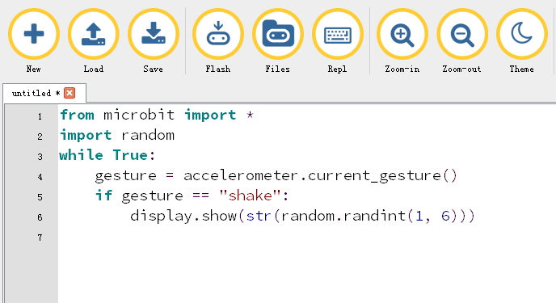

Figure 8-1

2.As shown in Figure 8-2, you need to click the Check button to check if our code has an error. If a line appears with a cursor or an underscore, the program indicating this line is wrong.

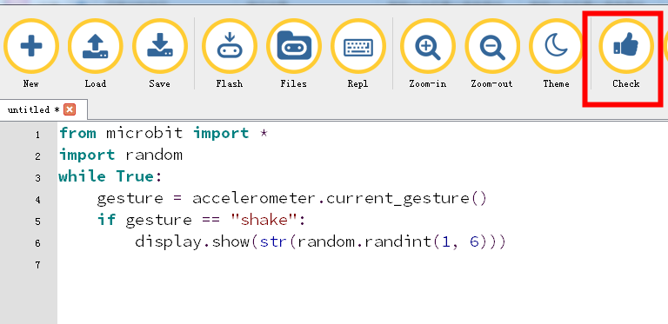

Figure 8-2

3.You need to connect the micro data cable to micro:bit and the computer, then click the Flash button to download the program to micro:bit as shown in Figure 8-3.

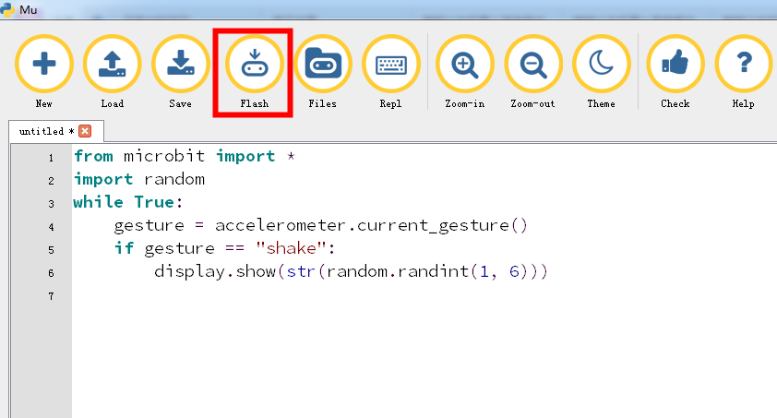

Figure 8-3

4. After downloading the program, shake a roll of micro:bit. There are number 1-6 randomly appearing on the dot matrix, which is exactly the same as playing the dice, as shown in Figure 8-4, Figure 8-5.

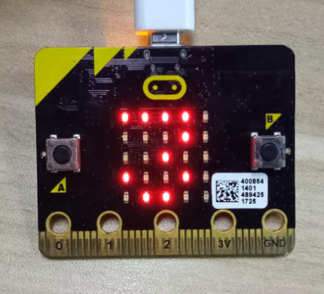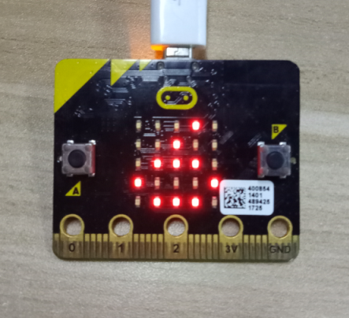

Figure 8-4 Figure 8-5